00000000000000000000000000000000000000000000000000000000000000000000000000000000000000000000000000000000000000000000000000

JC Rupe

Date: **March 29, 2017**

Version: **1.0.3**



**Project Eden:**

*Jarvis Application*

**IT Project Management Office**

Document Revisions

|  |  |  |
| --- | --- | --- |
| Date | Version Number | Document Changes |
| 2016/12/21 | 1.0.0 JC | Document initial creation/completion. |
| 2017/01/03 | 1.0.0 JC | Edited a small amount of the wording. Section 1.1. |
| 2017/01/09 | 1.0.1 JC | Moved the steps for viewing documented phone call and email. |
| 2017/01/12 | 1.0.2 JC | Edited more of the wording. Section 1.1. |
| 2017/01/17 | 1.0.2.1 JC | Added document name to footer. |
| 2017/03/29 | 1.0.3 JC | Added the “Choose Service Calls For” quick selection and modified a few screen shots. |
|  |  |  |
|  |  |  |
|  |  |  |
|  |  |  |
|  |  |  |

Contents

1 Jarvis Application 3

1.1 Important Information 3

1.2 Navigate and View Jarvis Application 3

1.3 Features – Jarvis 4

1.3.1 Service Activity Follow-up Display Grid Panel 4

1.3.2 Record Selection Criteria Panel 4

1.3.2.1 Choose Service Calls For 4

1.3.2.2 Record Selection Criteria 5

1.3.3 Action Panel 6

1.4 Send an Email Follow-up – Jarvis 7

1.5 Service Confirmation Call – Jarvis 8

1.5.1 Locate Desired Service Activity Record 8

1.5.2 Document a Service Confirmation Phone Call 8

1.5.3 Send a Service Call Confirmation Email 9

1.6 View Sent Email – Eden 10

1.7 View Documented Phone Call – Eden 10

1.8 Add Notes to Documented Phone Call – Eden 10

# Jarvis Application

The Jarvis tool is used to view and take action on Service Activities or Moves that need phone or email follow-up by the Move Coordinator. The Move Coordinator may use this to document the phone call or compose and send an email

## Important Information

* **Selecting a record, not a link in the record:** Try to select a part of the record line that doesn’t contain a link. Remember, text displayed in blue is a link. If you click on the link, it will open that items information page. For example if you select the name of the Contact, the Contact information page in Eden will open. If this happens, you may have to navigate back to the previous page or close the window that opened when you selected the link.
* When needed, Move Coordinators may perform follow-up contacts for other Move Coordinators.
  + **Note:** If you send an email follow-up for another Move Coordinator and find that it remains unsent with a status of Pending, contact the system administrator. Either you or the other Move Coordinator need to have your “Allow other Microsoft Dynamics CRM users to send email on your behalf.” personal option set correctly.

## Navigate and View Jarvis Application

The preferred browser to use is Microsoft Explorer, although, Chrome and Firefox should also work.

1. Navigate to the Jarvis Creation application.
   1. See your supervisor if you don’t have this link.
2. The Jarvis window will open and display.
   1. Displayed are 3 panels.
      1. The right panel displays the Service Activity follow-up display grid.
      2. The upper left panel is for setting the record selection criteria.
      3. The lower left panel contains action buttons.

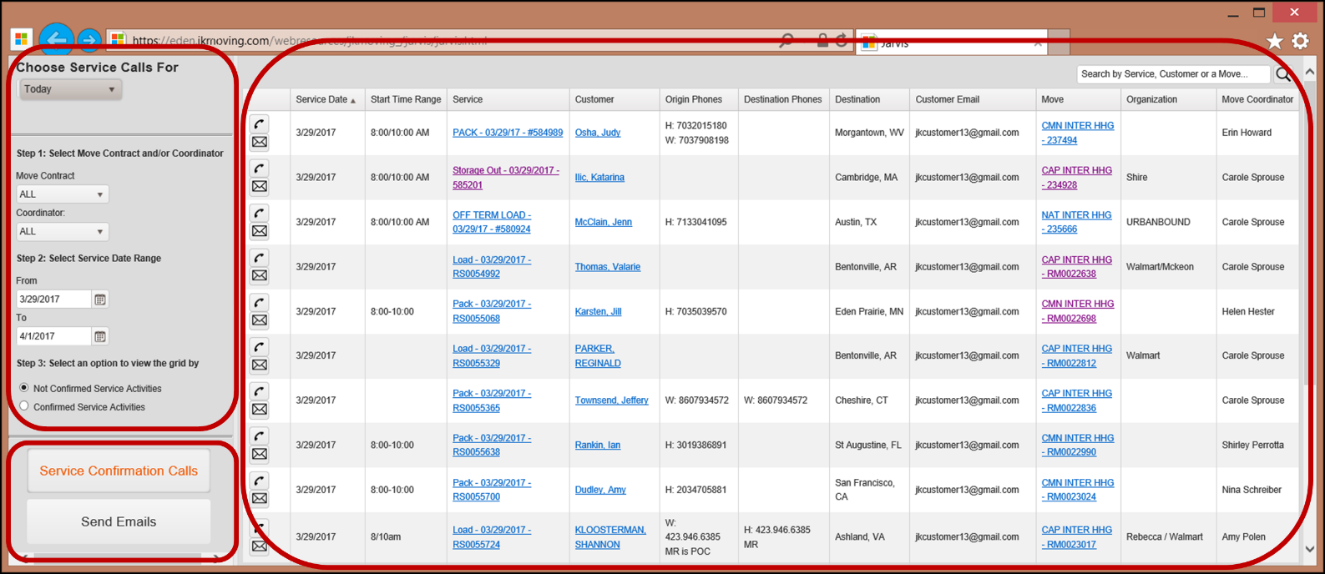

## Features – Jarvis

### Service Activity Follow-up Display Grid Panel

Displayed here are Service Activities that need either an email or phone call follow-up.

1. The display grid consists of 12 columns of information.
   1. **Action** that may be taken. Two buttons, one for placing a phone call and the other for sending an email.

.

* 1. **Service Date** – The date the Service Activity is supposed to be performed or started.
  2. **Start Time Range** – The start and end time range for the Service Activity.
  3. **Service** – The Service Activity number/name.
  4. **Customer** – The name of the Customer.
  5. **Origin Phones** – Contact phone number at the Move point of origin.
  6. **Destination Phones** – Contact phone number at the Move destination point.
  7. **Destination** – The Moves destination city and state.
  8. **Customer Email** – Contact email address.
  9. **Move** – The Move number/name.
  10. **Organization** – The organization that has contracted the Move to be performed.
  11. **Move Coordinator** – The single point of contact that assists the Client/Customer with planning the move and takes care of all the Clients moving needs.

### Record Selection Criteria Panel

Set the criteria for retrieving Service Activity records into the display grid. The options here are based on which action button is selected in the lower left panel, either “Service Confirmation Calls” or “Send Emails”. See Action Panel below.

#### Choose Service Calls For

This is a quick select for choosing the desired Service Date Range. It’s located at the top of the Record Selection Criteria Panel. Note: Selecting one of these options will overwrite the contents of the Service Date Range selection criteria.

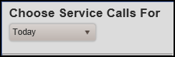

1. Options:
   1. **Today** – Displays Service Activities with Today’s date as their Service Date. Displays Moves that have Service Activities with Today’s date as their Service Date.
   2. **Tomorrow** – Displays Service Activities with Tomorrow’s date as their Service Date. Displays Moves that have Service Activities with Tomorrow’s date as their Service Date.
   3. **2 Day** – Displays Service Activities with Today, Tomorrow and the next 2 day’s dates as their Service Date. Displays Moves that have Service Activities with Today, Tomorrow and the next 2 day’s dates as their Service Date.

#### Record Selection Criteria

Set the criteria for retrieving Service Activity records into the display grid. The options here are based on which action button is selected in the lower left panel, either “Service Confirmation Calls” or “Send Emails”.

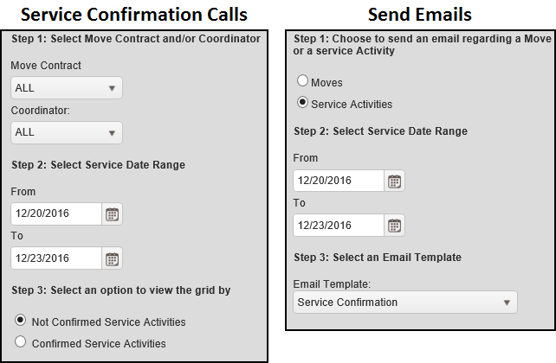

1. Service Confirmation Calls button selection:
   1. **Step 1:** Select Move Contract and/or Coordinator
      1. **Move Contract**
         1. Selection options:
            1. All
            2. Common Carriage
            3. Military
            4. GSA
            5. State Dept
            6. CapRelo Accounts
            7. National Accounts
      2. **Coordinator** – records for a specific Move Coordinator or All.
         1. Selection options:
            1. All
            2. Select from a list of named Coordinators
2. Send Emails button selection:
   1. **Step 1:** Choose to send an email regarding a Move or a service Activity
      1. Selection options:
         1. Moves
         2. Service Activities
3. Both button selections:
   1. **Step 2:** Select Service Date Range
      1. **From** and **To** dates – Enter a range of Service Dates whose action required records you want to display.
      2. Note: These dates are overwritten, when the quick select “Choose Service Calls For” is used.
4. Step 3 changes based on which Action Panel button is selected. See the next subsection, Action Panel.
   1. When the “Service Confirmation Calls” button is selected:
      1. **Step 3:** Select an option to view the grid by
         1. Selection options:
            1. Not Confirmed Service Activities
            2. Confirmed Service Activities
   2. When the “Send Emails” button is selected:
      1. **Step 3:** Select an Email Template
         1. Select from a predetermined set of email templates.

### Action Panel

Set the criteria for retrieving Service Activity records into the display grid. The button selection here determines what Record Selection Criteria options are displayed in that panel. See previous subsection Record Selection Criteria.

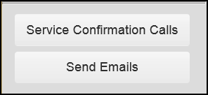

1. Select the action button.
   1. “Service Confirmation Calls” button
      1. Through this action selection, the phone call is documented in one of two ways.
         1. Entering the call details into a text field.
         2. Entering the call details into an email using the “Service Confirmation Email Template”.
   2. “Send Emails” button.
      1. Through this action selection, an email may be sent by selecting from a predetermined set of email templates.

## Send an Email Follow-up – Jarvis

1. Select the “Send Emails” button in the Action panel.
   1. The text inside the button will turn an orange color, indicating that it has been selected.
   2. The upper left Record Selection Criteria panel will redisplay with appropriate options.
2. Enter appropriate record selection criteria.

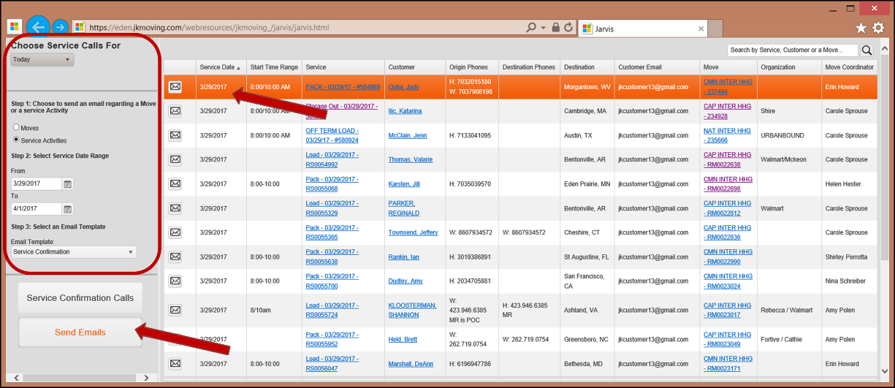

1. Locate and select to highlight the desired Service Activity record.
2. Select the Email button in the first column of the Service Activity record. 

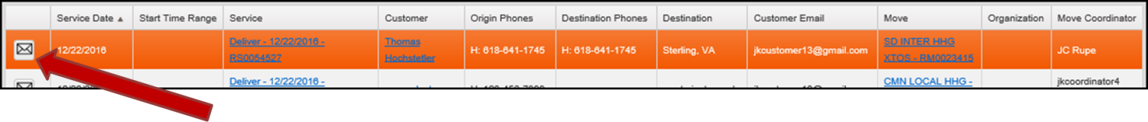

1. The email template will display. (In this pictured example, the “National Accounts Full Unpack Email Template” is being used.)
   1. The Customer Name and Email are already populated.
   2. The salutation contains the Customers name.
   3. Select the checkbox to “Include Move Consultant in the email”.
   4. The body of the email is populated with the template information, as well as, other pertinent information.
   5. The signature block at the end of the email is populated with that of the Move Consultant.
2. Make appropriate changes to the body of the email template, to customize it to your Customers Move.

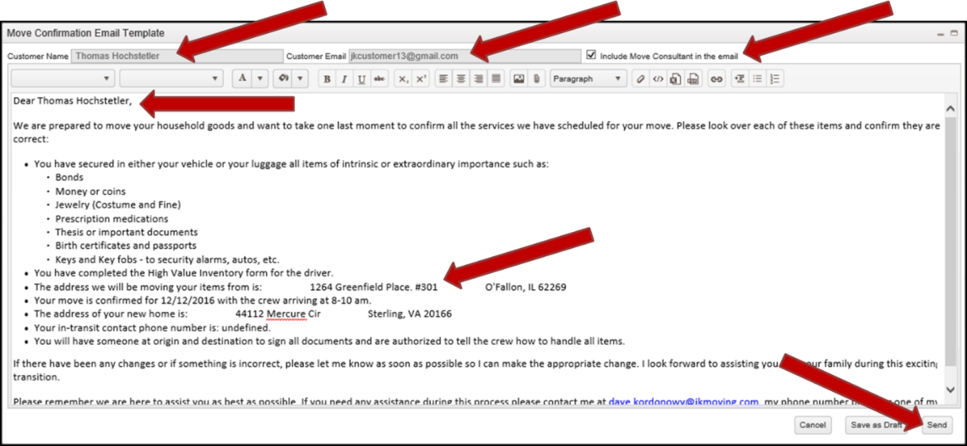

1. Select the “Send” button to send the email.
2. Ensure that the email was sent, by performing the steps in section View Sent Email – Eden.

## Service Confirmation Call – Jarvis

### Locate Desired Service Activity Record

1. Select the “Service Confirmation Calls” button in the Action panel.
   1. The text inside the button will turn an orange color, indicating that it has been selected.
   2. The upper left Record Selection Criteria panel will redisplay with appropriate options.
2. Enter appropriate record selection criteria.

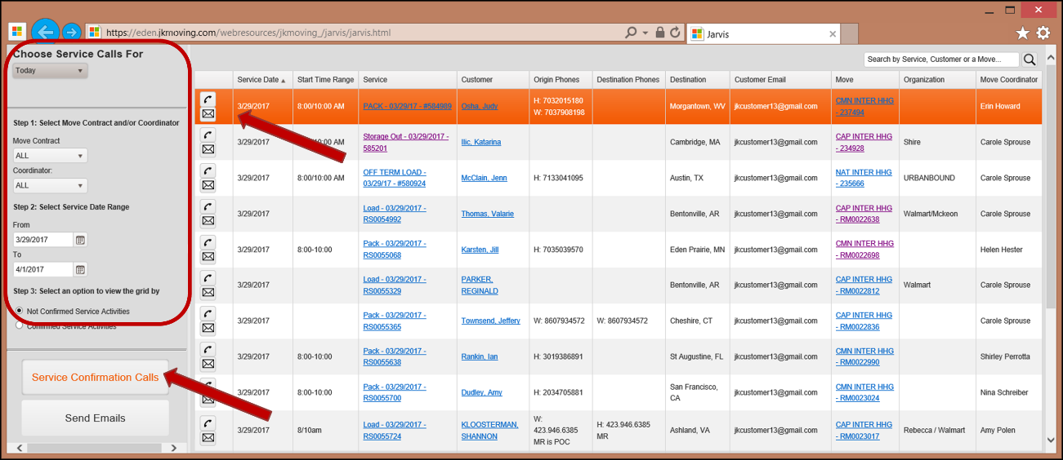

1. Locate and select to highlight the desired Service Activity record.
2. If you want to document a Phone Call, perform the steps in section Document a Service Confirmation Phone Call.
3. If you want to send an Email to confirm the call, perform the steps in section Send a Service Call Confirmation Email.

### Document a Service Confirmation Phone Call

1. Select the Phone button in the first column of the highlighted Service Activity record. 

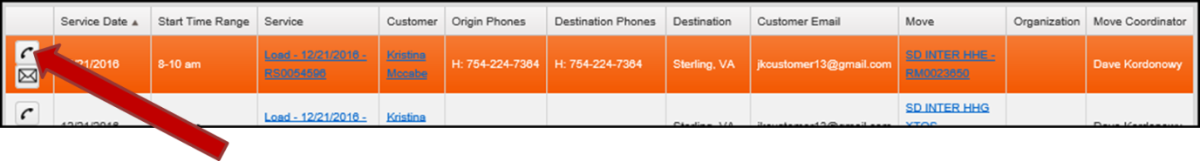

1. The “Enter Call Details for *Client Name*” page will display.
   1. Enter details about the phone conversation into the text entry area.
   2. This is free form and text only.

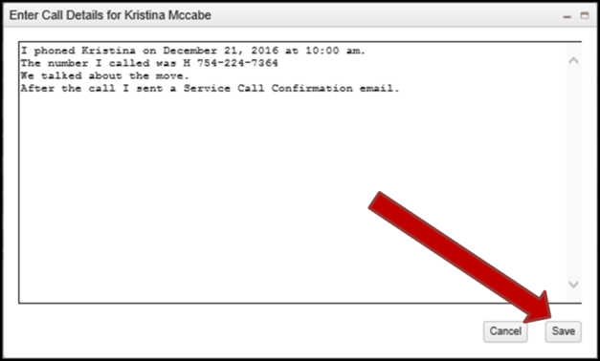

1. Select the “Save” button.
2. Ensure that the phone call was saved, by performing the steps in section View Documented Phone Call – Eden.

### Send a Service Call Confirmation Email

1. Select the Email button in the first column of the highlighted Service Activity record. 

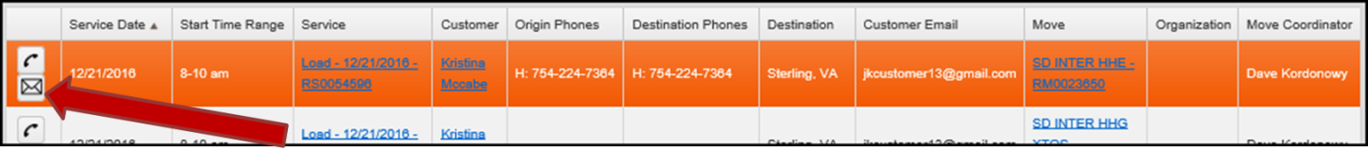

1. The “Service Confirmation Email Template” will display.
2. Make appropriate changes to the body of the email template, to customize it to your Customers Move.

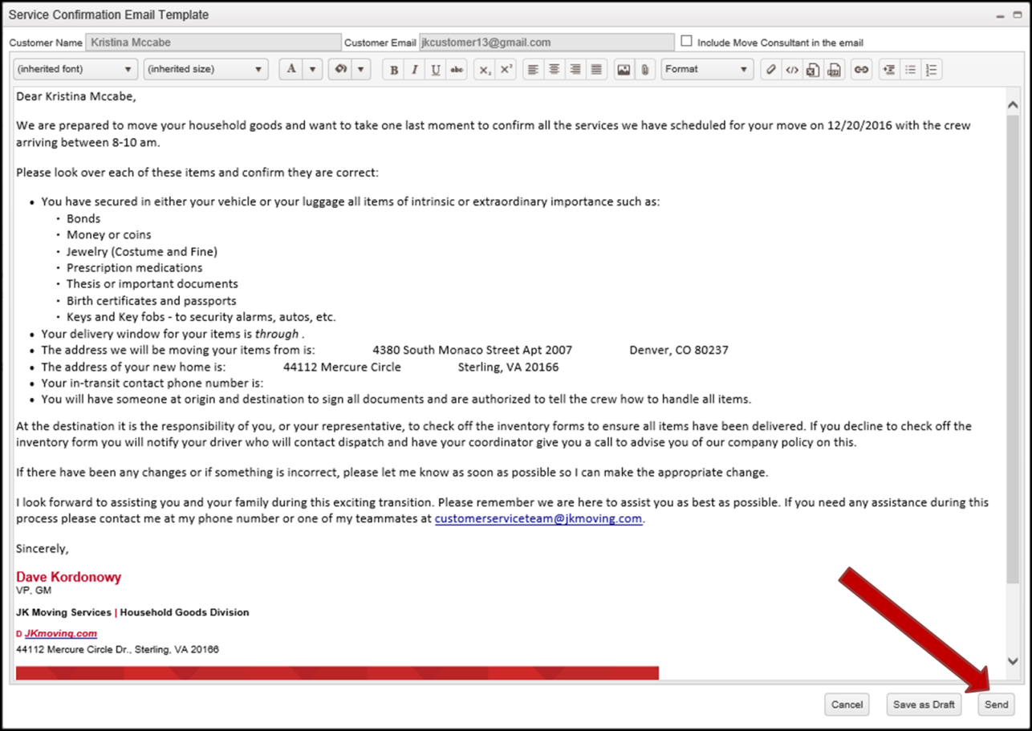

1. Select the “Send” button to send the email.
2. Ensure that the email was sent, by performing the steps in section View Sent Email – Eden.

## View Sent Email – Eden

To view a sent email, perform the steps found in the “EDEN – Customer Service Reference Guide”, section “View Email”.

## View Documented Phone Call – Eden

To view a documented phone call, perform the steps found in the “EDEN – Customer Service Reference Guide”, section “View Documented Phone Call”.

## Add Notes to Documented Phone Call – Eden

To add notes to a documented phone call, perform the steps found in the “EDEN – Customer Service Reference Guide”, section “Add Notes to Phone Call Activity”.